Global Challenge, Local Solutions: Changing Lives for Good
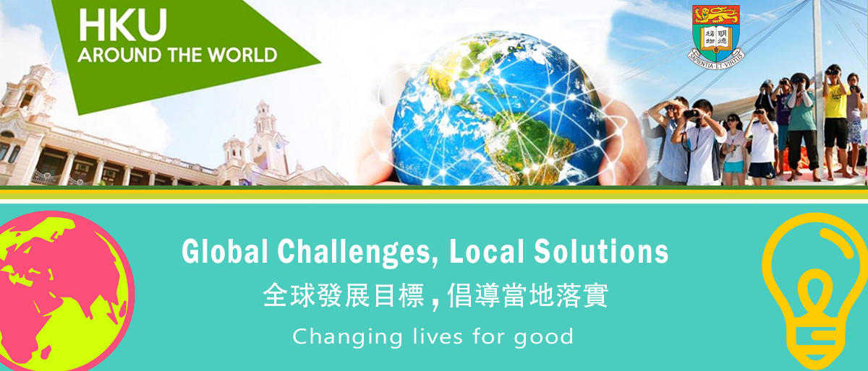

Application Form
Please complete this Application Form for the “Global Challenge, Local Solutions: Changing Lives for Good” student competition, and submit online at http://wp.cedars.hku.hk/form/wcc-hku2018.

The deadline to submit your application is 23 February 2018 (Friday). Good luck!

Team Leader (Key Contact Person)

Student ID: Click here to enter text.
Name: Click here to enter text.
Mobile: Click here to enter text.

Question 1
What global challenge will your team address? We encourage student teams to consider the Global Goals as part of their strategic approach.

Click here to enter text.

Question 2
Describe the global challenge and explain why your group is interested in it, and why it is important to work toward a resolution in 300 words.

Click here to enter text.

Question 3
Provide a brief outline of your team’s idea/project to address the chosen global challenge in 400 to 800 words).

Click here to enter text.

-- The End --

