Accompanied by Our Best Private Pilots, Experience the Powered Parachute
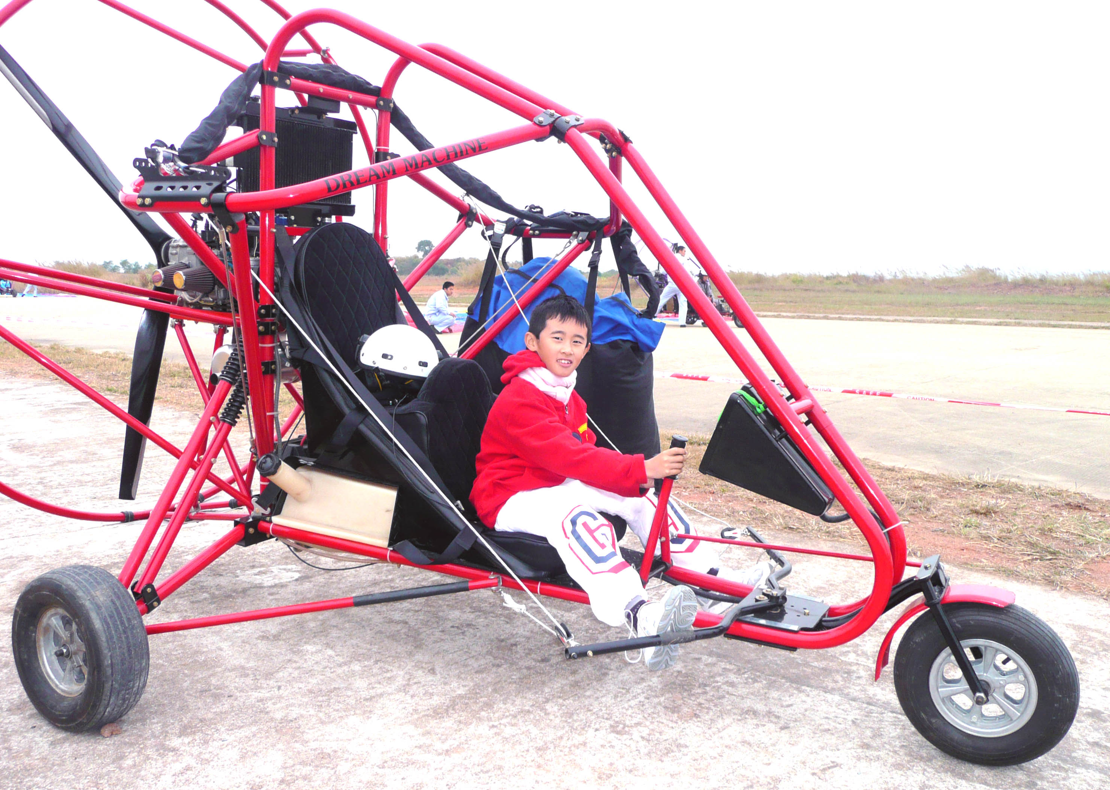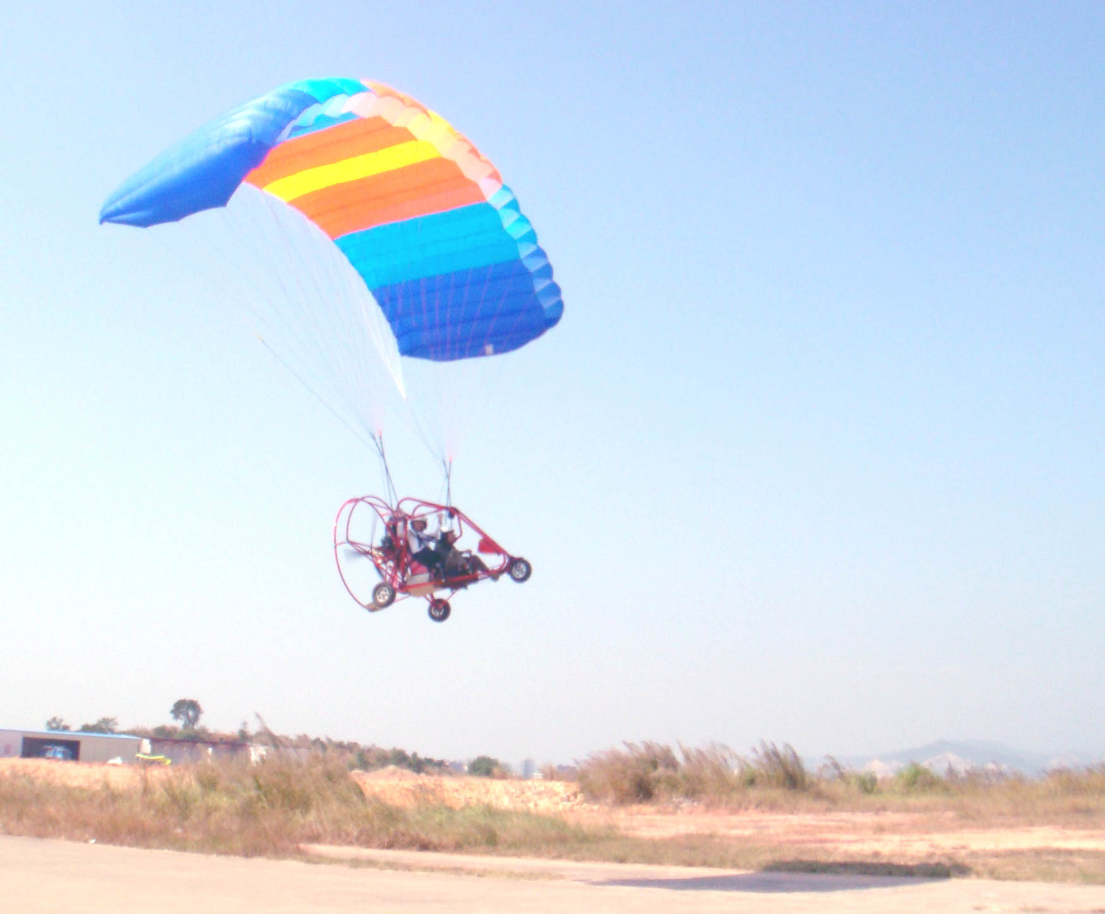
Suitable for All Ages 100% Flight Experience

Regarded as “the safest aircraft” in human history
Golden opportunity to experience yourself
Learn the basics of aviation and piloting
Brand-new experience, totally different from airplane or helicopter
Challenge yourself, Explore your potential, Enjoy the flight

Basic information
Date: | Before 31 Aug 2009
Time: | 8:45a.m. – 2:00 p.m. (Half day only, no accommodation provided)
Gathering Spot: | Gate 1, LuoHu Port. A flag will be set near the port canteen for your identification.
Dismissing Spot: | LuoHu Port
Language: | Putonghua
Schedule of Activities
Time | Activity
8:45-9:00 | Arrive at Luohu Port at designated time
9:00-10:30 | Take bus to Huizhou Danshui railway station (return fees are included already); the trip will take about 1.5 hours.
10:30-10:45 | Changed to shuttle bus and arrive at the flight site
11:00-12:00 | After a short rest, coaches will briefly introduce:  - The aircraft, aviation principles and flight rules;  - Each participant will be accompanied by one pilot in a 10 minute-flight;  - After the flight, participants can take photos within the safety zone.
12:00-12:15 | Participants will be led to take the direct bus to LuoHu Port by staff.
12:30-2:00 | Take the bus to Luohu Port.
2:00 | Arrive at Luohu Port. Participants may choose to stay in Shenzhen for lunch on their own expenses.  This is the end of the activity. Wish you a nice trip.

- Introduction : “CanFly.asia”
  - Chief organizer of “Flight Experience”, a private club in Hong Kong. Coordinate all events and related issues for members; aimed to gather all friends that are interested in flight sports and to promote and popularize flight sports.

- Organizer: “MiniU.asia”
  - Licensed travel agency in Hong Kong, license No.:353274, undertaker of “Flight Experience”.

- Introduction :“Powered Parachute”
- Powered Parachute was invented by the Americans in 1970s. After its commencement in 1983, it got increasingly popular in the amateurish aviation for its features like safe and reliable, easy to operate, convenient to maintenance. Besides the uses in leisure and military areas, the Powered Parachute has also been widely used in advertising, aviation photography, pesticide distribution and air monitoring, etc. Participants will have a bran-new experience, totally different from airplane or helicopter. They can touch the blue sky and feel the wind.

References：
Content | Links
Experience sharing by past participants | http://hk.myblog.yahoo.com/ivan9586/article?mid=62
Video about the flight by HK members | http://www.youtube.com/watch?v=puyXj-6hJs0
Hong Kong aviation groups | http://www.aircadets.org.hk/news/english/Msg07-281.pdf

This prize is sponsored by MiniU.asia

