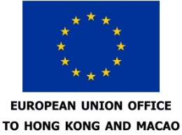
Application Form

International Women's Day 2019
EU & HKU Short Video Competition

Note: Please provide all required information. Incomplete applications will not be accepted.

- PERSONAL PARTICULARS (For groups, please provide the details of the team leader and list details of the other group member(s) on page 3 of this application form.)
Name in English alphabet: (Miss/Ms/Mr/Mx/Dr/Prof) | Full official name in Chinese or other languages that matches exactly the ID document provided:
First four digits of ID/passport number: | Nationality:
Gender identity:  Male  Female  Other | City of residence:
Select one option:
- Student individual group
- Staff/Alumni individual group
Contact no. (mobile): | Email address:
Postal address:
- ENTRY SUMMARY:
Entry title in English:

Entry title in Chinese or another language (if any):

Brief description of the content and treatment (no more than 50 words):

URL to the Entry Video:

- ENTRY SUBMISSION:
- A PDF file of the completed application form together with 2 film stills for promotional purposes not larger than 4 MB should be uploaded to the following e-form address: http://bit.do/EU-HKU-Video-Competition-Submission ON OR BEFORE 11 FEBRUARY 2019 (Monday).
- Each of the submitted videos must include the name, telephone number, and email address of the entrant/group. English subtitles are required for non-English language films. Please note that, once submitted, all entries will be deemed final and cannot be amended.
- Entries can be submitted by individuals or groups.
- The competition is intended for the HKU Community.

ENQUIRY:
Tel: +852 39175044, Email: gened@hku.hk
The EU & HKU Film Contest 2019 is hosted by the Office of the EU in Hong Kong and Macau and the Office of the Vice-President (Global) of The University of Hong Kong with the assistance of the Women’s Studies Research Centre (WSRC) and the Committee for Gender Equality and Diversity (CGED) in the Faculty of Arts. Further information on the EU & HKU video competition can be found at http://bit.do/EU-HKU-Video-Competition

- RULES AND REGULATIONS:
- Each entrant/group can submit a maximum of 1 video link via the following website: http://bit.do/EU-HKU-Video-Competition.
- The title of the video uploaded must match exactly the video title on the application form.
- The submitted video must be the original work of the entrant/group, who should ensure there is no infringement of copyright or the rights of others.
- The entrant/group must be the sole and exclusive owner of the copyright of the entry. Where there is more than one entrant to an entry, all of the entrants must be exclusive owners of the copyright of the entry. Entries should not infringe any rights of any third party.
- The entrant/group should only use third party music excerpts or film/video segments in the entry with the prior written consent of the relevant third party. The entrant/group must acknowledge any authorized use of music excerpts or film/video segments in the entry in accordance with the relevant copyright laws. The organizer shall not be responsible whether directly or indirectly for any liability arising whatsoever or howsoever from any violation of any copyright laws. The entrant/group agrees and undertakes to accept and be responsible for all such liability arising therefrom.
- If the winning project(s) is created by a group of more than one person, they will be considered as one person and therefore only one Prize will be awarded per winning project.
- During adjudication, the composition of the team (student/staff-alumni) will be taken into consideration.
- The organizer reserves the right to use any entry video for publicity, exhibition and publication purposes.
- The organizer has no liability regarding the quality, availability and warranty of the prizes supplied. Any dispute or complaint in respect of the prizes should be directed to the suppliers of the relevant prizes.
- The organizer will apply to the Television and Entertainment Licensing Authority (TELA) for a proper license for public screenings of the submitted films.
- All matters and disputes will be subject to the final decision of the organizer.

Signature of the Entrant: | Date:
Entry Deadline: 11 February 2019

Co-organised by:
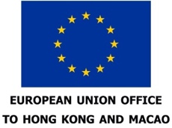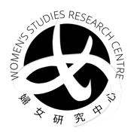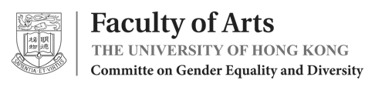

- PERSONAL PARTICULARS OF OTHER GROUP MEMBERS (IF ANY)
Name in English alphabet: (Miss/Ms/Mx/Mr/Dr/Prof) | Full official name in Chinese or other languages that matches exactly the ID document provided:
First four digits of ID/passport number: | Nationality:
Gender identity:  Male  Female  Other | City of residence:
Select one option:
- Student individual group
- Staff/Alumni individual group
Contact no. (Mobile): | Email address:
Postal address:

Please list any additional group members using the same format as above.

Personal Information Collection Statement
The personal information provided by you herewith will be used for the purposes and activities of and related to the International Women's Day 2019 EU & HKU Short Video Competition by The University of Hong Kong and the Office of the European Union in Hong Kong and Macao. Under the Personal Data (Privacy) Ordinance, you have the right to request access to and/or correction of your personal data held by the University. Requests should be made to the Data Protection Officer at privacy@hku.hk
The Privacy Policy Statement of the University can be accessed at http://www.hku.hk/privacy_policy/

